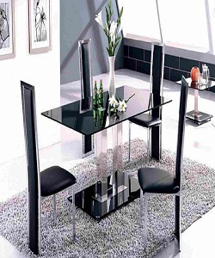

Universal Dining Table

$172.15

Availability: In stock

Description

Enjoyable black glass rectangle two base modern dining table and four modern dining chairs.